

Electrical Engineering Student  
University of Wisconsin - Platteville  
woerpela@uwplatt.edu  
920-988-5872

920-9885872

Engineering Design Portfolio

Andrew Woerpel

# Contents

Seljan Company Internship 2

Society of Automotive Engineers, Aero 5

Undergraduate Research 7

Boy Scouts of America 9

Appendix 10

# http://www.spacefoundation.org/sites/default/files/articles/images/ORBITEC.pngPlexus Corporation Internship

|  |  |
| --- | --- |
| Position: | Software/Product Engineering Intern |
| Duration: | Summer 2015 |
| Group Setting: | Worked in a team of 8 split between Neenah, WI and Boulder, Co. |
| Responsibilities: | Develop automated tests and the underlying framework to test product software. Develop a misuse test fixture for engineering confidence testing. |

# http://www.getfilings.com/sec-filings/130610/PLEXUS-CORP_8-K/pressreleasecooannoun_image1.jpgPlexus Corporation Internship

|  |  |
| --- | --- |
| Position: | Software/Product Engineering Intern |
| Duration: | Summer 2015 |
| Group Setting: | Worked in a team of 8 split between Neenah, WI and Boulder, Co. |
| Responsibilities: | Develop automated tests and the underlying framework to test product software. Develop a misuse test fixture for engineering confidence testing. |

# Continuous Integration Platform Software Development

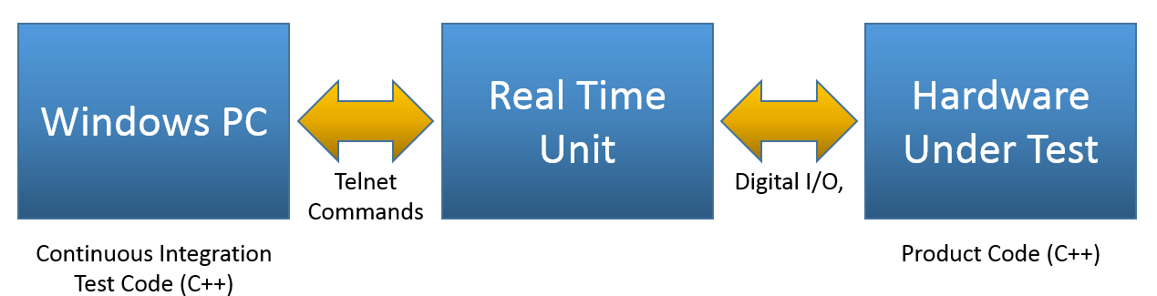

Most of my time was spent creating and correcting C++ code for a continuous integration test system that was used to test every feature of medical device. The code base was approximately 70,000 lines, with tests ranging in length from 30 minutes Over 24 hours.

Notable Project Achievements

* Fixed countless bugs
* Refactored widely used and complex segments of code that were causing intermittent failures due to telnet communication latency
* Identified and fixed inconsistencies between code and test procedures
* Improved logging messages to increase consistency and human readability
* Wrote a signification number of tests from scratch

Tools and Techniques



* Agile software development method
* Tourtoius SVN (software version control)
* Atlassian JIRA (Issue tracking)
* JAMA (Product Development/Requirement Tracking)
* Atlassian Bamboo (continuous integration/code automation)

# Misuse Test Fixture

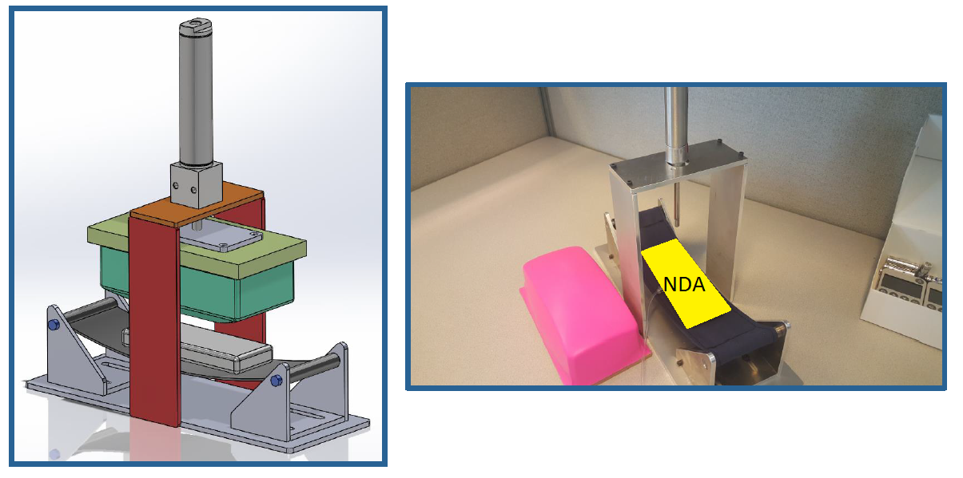A small portion of my time was spend designing a misuse test fixture for a medical device. The test fixture simulates someone putting the device in the back pocket of their pants and repeatedly sitting on it. I was responsible for the design of this fixture and even sewed the sling that the device sits in. The medical device is covered due to the confidentiality of the project.

Solid model of the test fixture (left). Fully fabricated unit and silicone pad (… I didn’t choose the color) (right).

# Seljan Company Internship

|  |  |
| --- | --- |
| Position: | Mechanical Design Intern |
| Duration: | During College Breaks Summer 2013 – Winter 2015 |
| Group Setting: | Mostly Independent with occasional assistance from upper management and engineers |
| Responsibilities: | Every aspect of projects, from initial design to final implementation |

# Powder Coating Operation

|  |  |
| --- | --- |
| **Approximate Project Cost:** | $50,000 |
| **Project Length:** | 3 months |
| **Period:** | Summer 2013 |

For my first project as an intern at Seljan Company, I was tasked with setting up the infrastructure that would allow them to begin powder coating their products.

Project Details

* Researched process and obtained equipment quotes from equipment suppliers and consumable vendors
* Presented plan to upper management for approval
* Designed and built steam cleaning booth and mobile racking
* Lead team to assemble powder coating oven and powder application booth

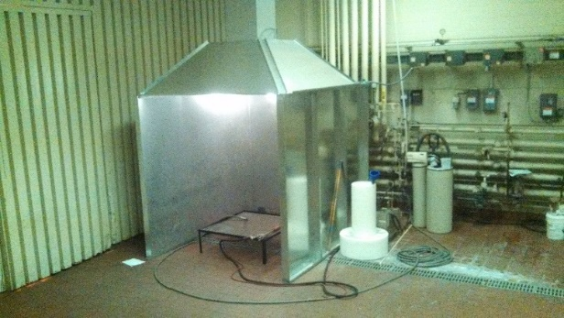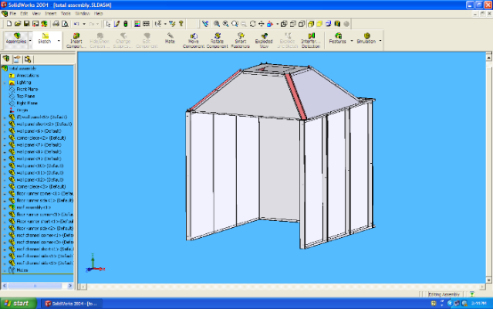

Solid model of steam booth and end result. The square ductwork leading to the ceiling is connected to an existing exhaust fan, for steam removal.

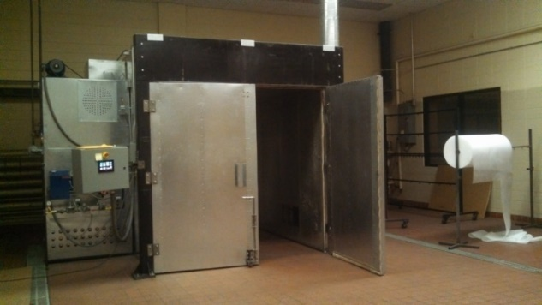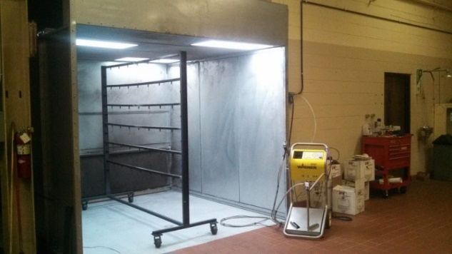

Images showing the 8’x10’x8’ powder coating oven, as well as the powder application booth, powder application gun, and adjustable cart.

# Conveyor System

|  |  |
| --- | --- |
| **Approximate Project Cost:** | $2,500 |
| **Project Length:** | 2 months |
| **Period:** | Summer 2014 |

For my second summer as an intern, I was in charge of creating a system that would remove metal stamping slugs from the back of several large punch presses. Prior to my arrival in the summer, Seljan Company had bought two used industrial quality conveyors, totaling around $5,000, with hopes of using them for this job. It was quickly determined that these were not adequate for this specific job since the slugs would get jammed in the chain drive system, causing the conveyor to stop. Instead of trying to modify these conveyors, I suggested that we build our own and promised that these would work better for this specific job than any commercially available system, and at a fraction of the cost. After some reluctance, I was allowed the opportunity to build a prototype of the conveyors that I had suggested.

Project Details

* Salvaged drive units from used conveyors
* Purchased required components
* Designed two custom conveyors to move slugs into recycling bin
* Assembled final units

Project Highlights

* Have been running almost continuously for over 1 year without breaking down
* Have moved approximately 100 tons of slugs

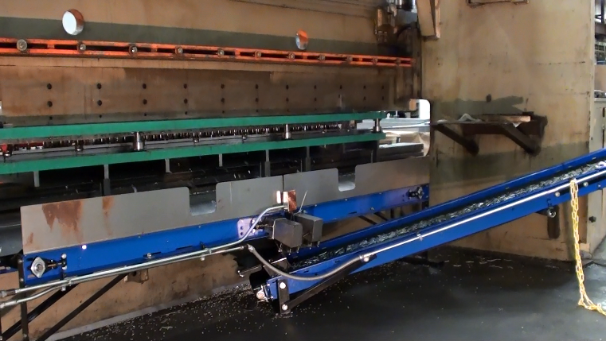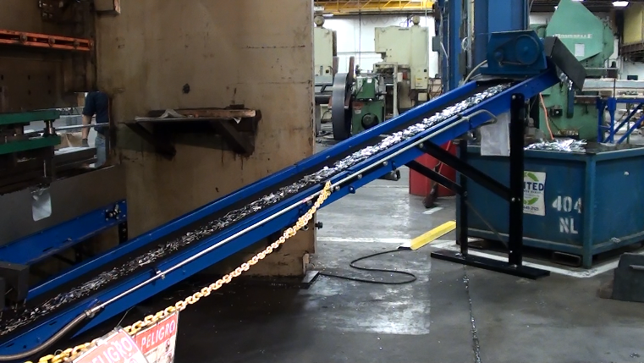

Shows the conveyor system removing slugs from the back of a 300 ton press break. Prior to the creating of this system, the slugs fell on the floor and were removed using scoop shovels.

# Pallet Construction Operation

|  |  |
| --- | --- |
| **Project Length:** | 3 weeks |
| **Period:** | Winter 2013 |

Seljan Company had recently began producing specific parts in such volume that the cost of purchasing pallets from a supplier was becoming quite expensive. Therefore, over winter break I was tasked with creating a process and the equipment necessary to construct these specific pallets. I designed and built an adjustable assembly fixture, a saw table with easily adjustable end stop, and saw horses for this project.

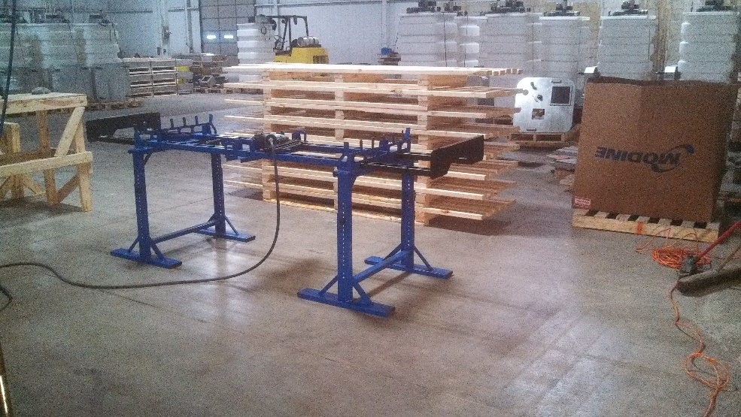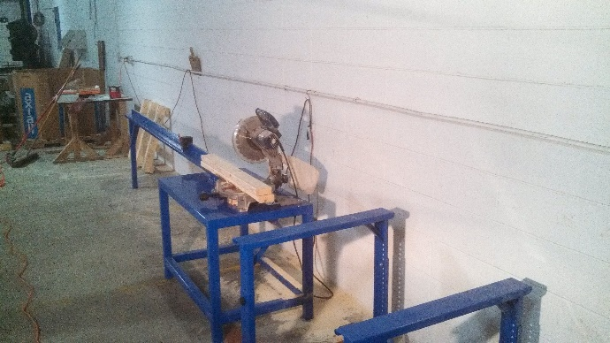

Shows the pallet assembly fixture and finished pallets, as well as the lumber sawing station.

# Society of Automotive Engineers (SAE), Aero Design Team

|  |  |
| --- | --- |
| Position: | Electrical Engineer |
| Duration: | Fall 2014 - Present |
| Group Setting: | Work as a team with freshman EE student |
| Responsibilities: | Project management, communication with team, hardware/software design and construction |

The recently created Aero team at UW – Platteville did not have any members who were Electrical Engineers students until myself and another student joined the team. Because of this, the power system for their previous plane was not utilized to its full potential. Furthermore, the motor/propeller test stand that they were using had a large amount of parasitic friction, lacked the ability to produce consistent tests, and required handwritten data collection. It was our goal to greatly improve this system by completely redesigning the stand and automating the testing process.

# Automated Motor/Propeller Test Stand

|  |  |
| --- | --- |
| **Project Length:** | 4 months |

Project Contributions

* Designed and built test stand
* Designed circuitry that allows a Teensy 3.1 microcontroller to measure instantaneous current, voltage, thrust, and motor speed.
* Wrote program in Python to
  + Initialize the test stand
  + Send data acquisition commands
  + Send motor control commands based on scratch built PID controller
  + Scale, store, and display the results of a test

Shows the test stand (powder coated UW – Platteville colors) and the strain gauge used to measure thrust.

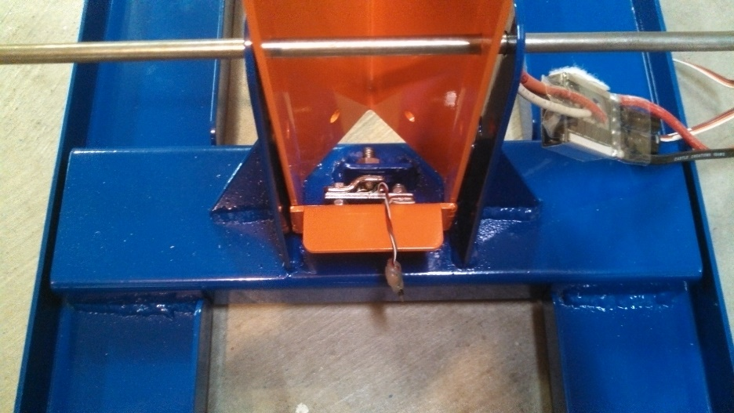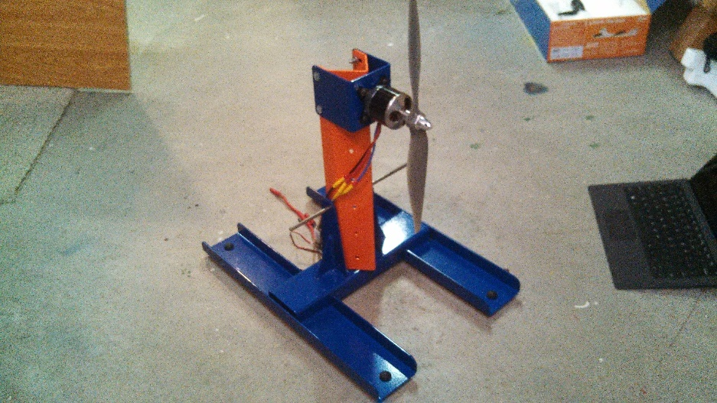

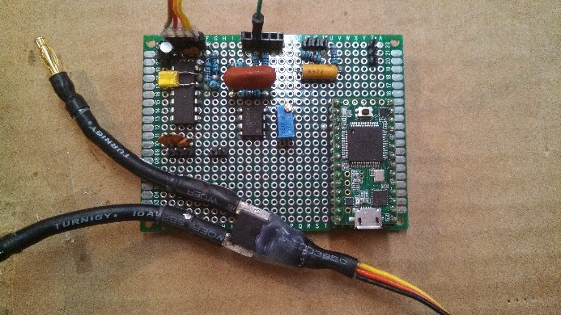The aspect of this project that I am most proud of is the throttle controller that I built in software. Competition rules place the maximum power that the electrical system can consume at 1000 W, and require that each team install a power limiter in their plane that shuts off the motor in the event that the plane goes over this limit. For this reason, it will be very valuable to have a controller that will manage the throttle of the motor based on the desired power consumption of the system. A similar controller will be implemented in the competition plane to ensure that the maximum allowable power is being consumed, without fear of exceeding the competition limit. The team feels that the power system improvements along with a larger aspect ratio wing will allow us to best the fourth-place finish that was achieved last year.

Shows the data acquisition circuitry and microcontroller.

**See Appendix for an example power and thrust graph**

# Undergraduate Research in Microsystems & Nanotechnology

|  |  |
| --- | --- |
| Duration: | Spring 2014 - Present |
| Group Setting: | Mostly independent with some guidance from faculty advisor and lab manager |
| Responsibilities: | Designing, conducting, and analyzing tests on samples |

My involvement in undergraduate research began when I approached one of my professors about partaking in such an opportunity. She tasked me with refining a procedure for creating nanostructures using a process called nanosphere lithography. After working on this project for a year with encouraging results, I changed the focus of my research to the fabrication of graphene nanotransistors using electron beam lithography.

**My research with nanosphere lithography was selected to represent the University of Wisconsin – Platteville at an event called “Posters in the Rotunda” in April of 2015 at the state capitol building in Madison, Wisconsin. At this event (pictured above), I had the opportunity to show my research to state legislators, University of Wisconsin System leaders, Students, and Alumni.**

# Nanosphere Lithography

|  |  |
| --- | --- |
| **Project Length:** | 1 Year |
| **Period:** | Spring – Fall 2014 |
|  |  |

The basic steps for this type of lithography are as follows.

* Clean substrate
* Spin coat 1 µm (or smaller) spheres on surface of substrate
* Deposit metal over substrate using the spheres as a mask
* 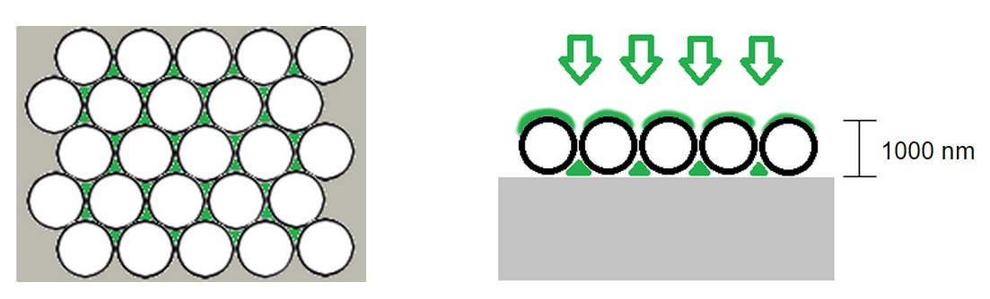Remove spheres from surface to expose nanostructures

Shows illustration of sphere arrays on surface, and the areas where the deposited metal (green) adheres to the substrate (left). A cross-section view of metal deposition is shown on the right.

E:\#Andy\MSNT Research\Fall 2014\Random\3d2.tifShows a scanning electron microscope image of the boundary of where spheres were removed. The nanostructures that are left are approximately 200 nm across.

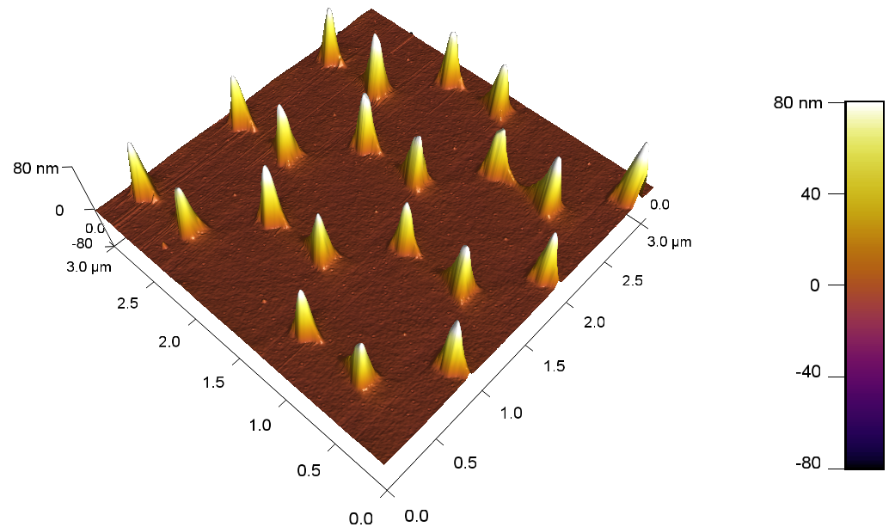Shows an atomic force microscope image of several nanostructures.

# Boy Scouts of America

|  |  |
| --- | --- |
| Position: | Senior Patrol leader,  Assistant Senior Patrol Leader,  Instructor |
| Duration: | 2001 - 2012 |
| Group Setting: | Mostly worked in teams and small groups |

# Eagle Scout Service Project

|  |  |
| --- | --- |
| **Project Length:** | 5 Months |
| **Period:** | Spring 2010 |

For my Eagle Scout project, a group of volunteers and I built a 33 ft long ladder bridge over a small ravine at my local mountain biking trails. I designed the bridge in SolidWorks, raised the needed capitol, and then lead a team to construct and install the bridge at the site. Two bridge sections of approximately 15 ft each and were mounted on top of cast concrete footings weighing approximately 1200 lbs. In total, the project took 148 man-hours of effort from volunteers and myself.

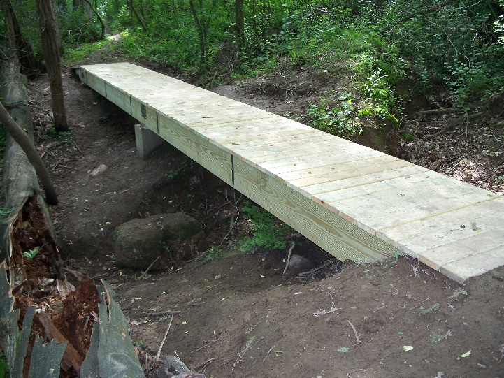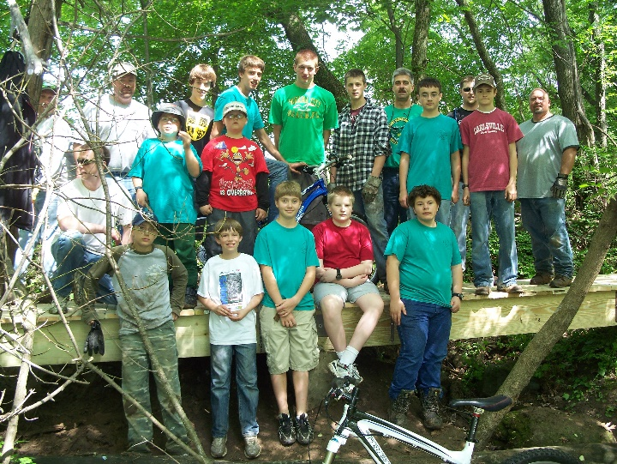

Shows images of the bridge and the team the helped me complete the project.

# Appendix

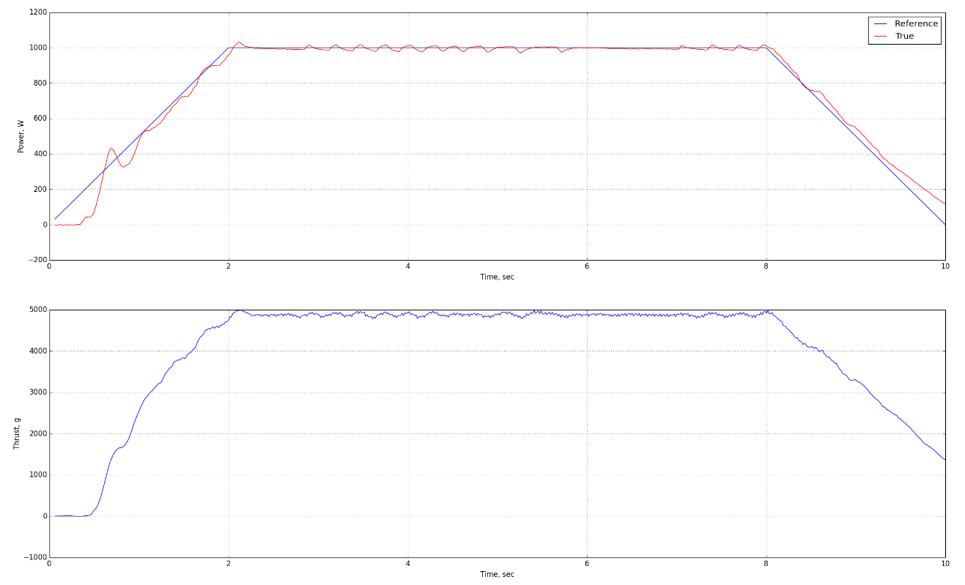

Image of the graphs that are generated by the SAE test stand.

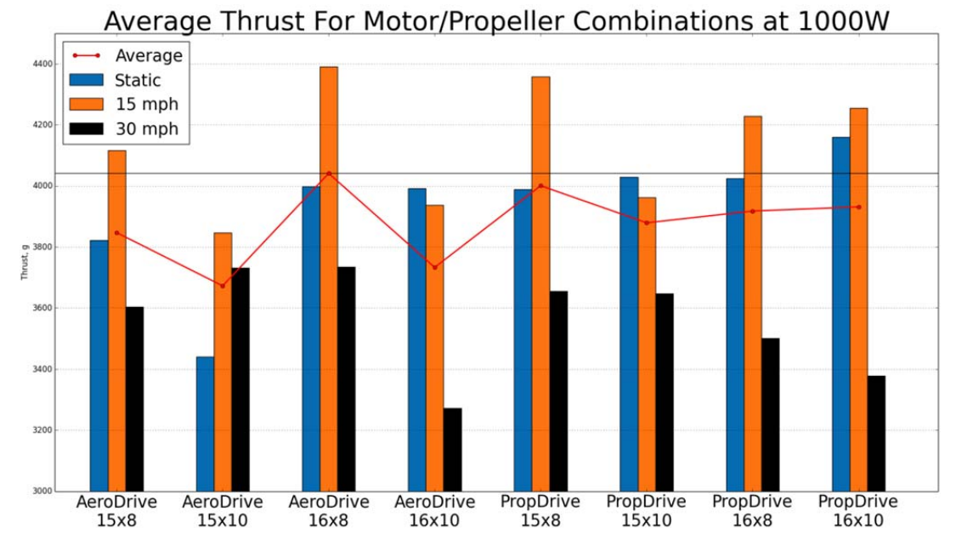

Bar graph showing average thrust for different props/motors at 1000W and different airspeeds.